**CURRICULUM VITAE**

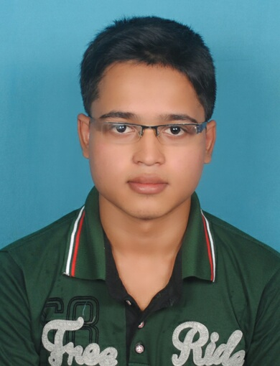

# NAME : CHANDAN KUMAR SAHOO

**S/o :** NABA KISHORE SAHOO

**At / Po :** ATHGARH

**Dist. :** CUTTACK

**STATE :** ODISHA

**Email:** Archandankumar75@gmail.com

**Contact no :** 9114949151

|  |
| --- |
| **CAREER OBJECTIVE :** |

To seek challenging and responsible position in an organization, where I can prove my capabilities with sincere efforts. I am always willing to embrace new skills, in order to remain in tune with advancing technologies.

|  |
| --- |
| **EDUCATIONAL QUALIFICATION:** |

|  |  |  |  |  |  |
| --- | --- | --- | --- | --- | --- |
| **Qualifying**  **Examination** | **Board**  **or**  **University** | **Name**  **of the Institution** | **Percentage** | **Division/**  **Grades.** | **Year**  **of**  **passing** |
| **BCA** | UTKAL University  ODISHA. | Arya schools of  Management&IT  Bhubaneswar |  |  | PRESENT |
| **10+2**  **(COMMERCE)** | CHSE,ODISHA | G.sc. college  ATHGARH | 52.83% | 2nd | 2016 |
| **10TH** | BSE,ODISHA | B.N BIDYAPITHA  ATHGARH | 62.83% | B2 | 2014 |

|  |
| --- |
| **PERSONAL PROFILE:** |

**Father’s Name :** Mr. Naba Kishore sahoo

**Mother’s name :**Smt. Pravati Sahoo

**Date of birth :**19/JULY/1998

**Gender :**Male

**Marital Status :**Unmarried

**Nationality :**Indian

**Religion :**Hindu

**Category :** OBC

**Languages known :** English, Hindi, Oriya

**Interest :** Internet Browsing,

**Hobbie :**Surfing web, Listening Music , Exploring new Technology

**Strength :**Patience, Confidence and Honesty

**Extra Curriculum : NCC**

**Computer Knowledge :**  Ms-word, Ms-excel, Ms-power point

**Permanent Address**: **Present Address:**

Chandan kumar sahoo. Chandan kumar sahoo

S/o : Naba kishore sahoo. LIG -373 K4

At / Po :ATHGARH. Kalinga vihar

Dist: cuttack. Bhubaneswar

State: Odisha. Pin : 751019

Pin : 754295

|  |
| --- |
| DECLARATION: |

I hereby declare that all the data and information provided above are true and correct to the best of my knowledge and I hold responsible myself for any irregularities if found.

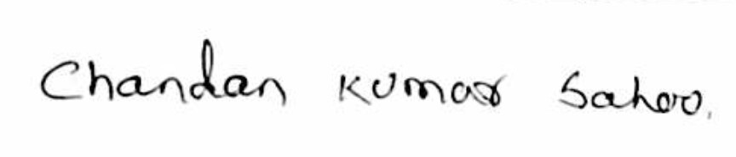

**Date:**

# Place: Bhubaneswar (chandan kumar sahoo)